Health in Eastern Europe & CIS

Strengthening sustainable international cooperation and
supporting the modernization of the health care systems

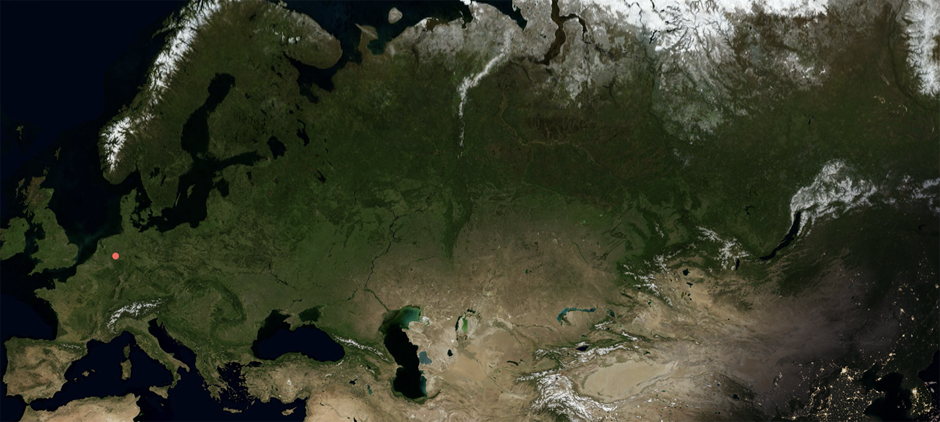

- Introduction: The position of the German healthcare industry in Eastern Europe
- Essential requirements for a successful cooperation
- Country specific requirements for closer cooperation
  - Russian Federation
    - Market Access
    - Services on medical equipment
    - Supporting the national cancer strategy
  - Ukraine
  - …

- Introduction: The position of the German healthcare industry in Eastern Europe

The health care industry is a high-tech market on an expansion course with outstanding importance for Germany as an industrial location and growth potential in the partner countries of the German Eastern Business Association and the German Health Alliance. The Corona crisis once again makes the overriding importance of international cooperation in the health sector very clear. For the period following the immediate threat of the pandemic, it is of outmost importance to join forces and leverage synergies in order to advance the modernization and resilience of the health care system in Eastern Europe and Central Asia.

The effectiveness of the health care systems is one of the most important factors not only in coping with the economic situation caused by the pandemic but also one of the key variables in ensuring the sustainable societal development and investment attractiveness of any country. The health care systems in Eastern Europe are in a phase of development and modernization, turning them into growth markets and highly valued partners of the German health industry.

International cooperation should gain in importance as a result of the crisis, as the global challenges triggered by the crisis can only be solved together. International cooperation, joint efforts to trigger inclusive modernisation and reform steps, but also prevention are the focus of attention. It would be short-sighted to limit oneself to the immediate fight against COVID-19. Attention should be paid to the general disaster preparedness of countries and companies, both in Germany and in the countries of Eastern Europe.

The state of development of the health care sector in Germany shows the performance and innovation capability of German healthcare companies. The possibility to introduce innovative solutions and know-how into the Eastern European markets plays an essential role for the German healthcare industry, which is growing steadily at an average of 4.1% per year (since 2010). According to the German Federal Ministry of Economics, exports of the German health care industry in 2019 amounted to over 131 billion euros, or 8.3% of total exports. The industrial health care industry accounted for over 90% of sectoral exports. In 2019, more than half of all exports of medical technology goods went to the European Union and the rest of Europe (including most of our partner countries in the region).

The health markets in Eastern Europe with their important stakeholders are not only highly valued partners, there are also drivers of innovation: Particularly in areas where healthcare systems can still be greatly modernized, the freedom to shape them is enormous. In these countries, there is a high level of willingness to implement new (digital) technologies, which is often viewed more critically in countries with more mature healthcare systems.

- Essential requirements for a successful cooperation

The Working Group on Health and Medical Technology represents the innovative health care industry in the East European markets. It provides an information and networking platform to promote the innovation partnerships with the countries in Eastern Europe and Central Asia with leading German companies, experts and political representatives from Germany and Eastern Europe. As industry representatives we are pursuing following goals to inclusive, innovative cooperation in the field of health care and medical technology:

- Enabling sustainable and transparent expert dialogue between government officials from the partner countries and German companies

- Providing access to innovative solutions in medical technology, pharmaceutics and biotechnology, but also in the field of resource and capacity management, disaster preparedness

- Highlighting of the importance of functioning supply chains and flows of goods and workers for the health industry

- Focus on market access, localisation and specific conditions

- Ensuring transparency of public procurement and creating a level playing field for local and international companies

- Creating an information and network platform for interested companies in the National projects in health care (e.g. Russia and Central Asia)

- Ensuring a multi-stakeholder cooperation approach between German companies, policy makers, local companies, universities

- Country specific requirements for closer cooperation

  - Russian Federation

The world’s largest nation, Russia remains an attractive market for the German Healthcare industry - despite the current rough economic period. The on-going COVID-19 pandemic has clearly demonstrated the need of an increased international cooperation in the field of health in general, but especially when medical technologies such as laboratory equipment needs to be developed and brought to market in a very short period of time.

German Healthcare companies are ready to support Russia not only in the fight against the Pandemic but also in addressing other national Healthcare needs. Therefor it is necessary that conditions for market access, operating services and reimbursement are innovation friendly and stable. Following arguments were collected by German Healthcare companies in order to highlight them during political talks.

    - Market Access

There is an interest in further easing of market access of the latest medical equipment and innovative software for medical purpose. The proposal is to analyze the rationale for a special fast-track procedure for major multinational corporations in the field of medtech. This could contribute to further growth of Russian citizens’ life expectancy. The registration takes currently 1-2 years for new modalities as well as for software, because software is handled as a medical product in Russia.

    - Services on medical equipment

Currently it is no necessary that service providers are certificated in the field of the services they offer. This could lead to major problems as the service is mostly not qualified and technicians without any special training are repairing and maintaining high complexity medical equipment. In the worst case this could lead to patient damage. Our propose would be a certification system which ensures the necessary knowledge.

    - Supporting the national cancer strategy

The quality of healthcare and Russian citizens’ life expectancy growth are the expected outcomes of the Healthcare programs of the Russian Federation. One of them, extremely actual for the current situation in healthcare, is the National Strategy for Oncological Disease Control for the period from 2019 to 2030. According to the Ministry of Healthcare of the Russian Federation, cancer is on the second place in the structure of mortality of Russian citizens. The National Strategy for Oncological Disease Control for the period from 2019 to 2030 is now in the process of approval and is the first initiative in the country forming the priority of oncology as social and medical problem and creating the framework for the legislative regulation of cancer care on the level of the RF Government. The target of the Strategy is the reduction of cancer-attributable mortality as well as the quality of life growth for the patients with oncological diseases.

The cancer program provides the opportunity for the systemic development of specialized healthcare providers. The Russian Government expects to have specialized healthcare providers in oncology as a widespread chain which will only focus on cancer.

The national strategy may become one of the priorities of healthcare system in Russia. We know that Russia wants to achieve European levels of cancer survival by 2024. In EU countries the fatality rate is currently 17% and in Russia it is 22.5%. German healthcare industry with their specific product portfolio in the field of oncology is ready to support the strategy and would like to be a partner for the Russian Government.

  - Ukraine

